

AECHE

YEAR 11 CHEMISTRY

TEST 2

Mole Theory and Stoichiometry
and
Rates of Chemical Reactions

MULTIPLE CHOICE SECTION

DO NOT WRITE ON THIS BOOKLET

PLEASE DO NOT TURN THE PAGE UNTIL INSTRUCTED TO DO SO

Total Recommended time: 50 minutes
SECTION 1 – MULTIPLE CHOICE – Answer on answer booklet provided

- Given the potential energy diagram for a chemical reaction:
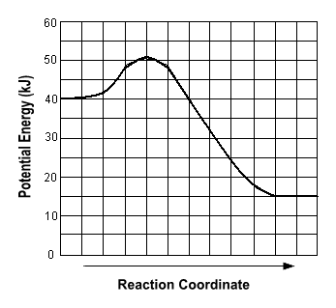
Which statement correctly describes the energy changes that occur in the forward reaction?
  - The activation energy is 10 kJ and the reaction is endothermic
  - The activation energy is 10 kJ and the reaction is exothermic
  - The activation energy is 50 kJ and the reaction is endothermic
  - The activation energy is 50 kJ and the reaction is exothermic

- Which one of the following processes is exothermic?

  - Li(g) → Li⁺(g) + e⁻
  - H₂(g) → 2H(g)
  - H₂O(l) → H₂O(s)
  - NaCl(s) → Na⁺(aq) + Cl⁻(aq)

- Propane is often used as a fuel in portable barbeques. The equation for the reaction is:

C₃H₈ (g) + 5O₂ (g) → 3CO₂ (g) + 4H₂O (g)
This reaction is
  - Exothermic and the enthalpy of the products is less than that of the reactants.
  - Endothermic and the enthalpy of the products is less than that of the reactants.
  - Exothermic and the enthalpy of the products is greater than that of the reactants.
  - Endothermic and the enthalpy of the products is greater than that of the reactants.

- Zinc metal reacts with hydrochloric acid to form hydrogen gas and zinc chloride solution. The production of hydrogen gas is more vigorous if the zinc is powdered, rather than in large pieces, because:

  - The activation energy of the reaction is lower.
  - The activation energy of the reaction is higher.
  - The frequency of collision between zinc metal and hydrogen ions is higher because of an increase in surface area.
  - The proportion of reactant particles with sufficient energy to react is higher.

- Which of the following procedures would result in a decrease in reaction rate for the following system?
C_{(s)} + 2H_{2 (g)} CH_{4(g)} H = -75 kJ mol⁻¹
  - Crushing the carbon before placing it in the reaction chamber.
  - Injecting more hydrogen gas into the reaction chamber.
  - Increase the volume of the reaction chamber whilst at constant temperature.
  - Increase the temperature of the system.

- Consider the following reaction.
2CO_{(g)} + 2F₂ _{(g)} + CCl₄ _{(g)} → CF_{4 (g)} + 2COCl₂ _{(g)} + 766 kJ
The reaction is:
  - Endothermic with ΔH = 766 kJ mol⁻¹ COCl₂
  - Endothermic with ΔH = 383 kJ mol⁻¹ COCl₂
  - Exothermic with ΔH = -766 kJ mol⁻¹ COCl₂
  - Exothermic with ΔH = -383 kJ mol⁻¹ COCl₂

The next two questions (7 and 8) refer to the information below.

The following diagram shows the changes in Potential Energy for the reaction:

N_{2 (g)} + O_{2 (g)} 2NO _{(g)} ΔH = +180 kJ

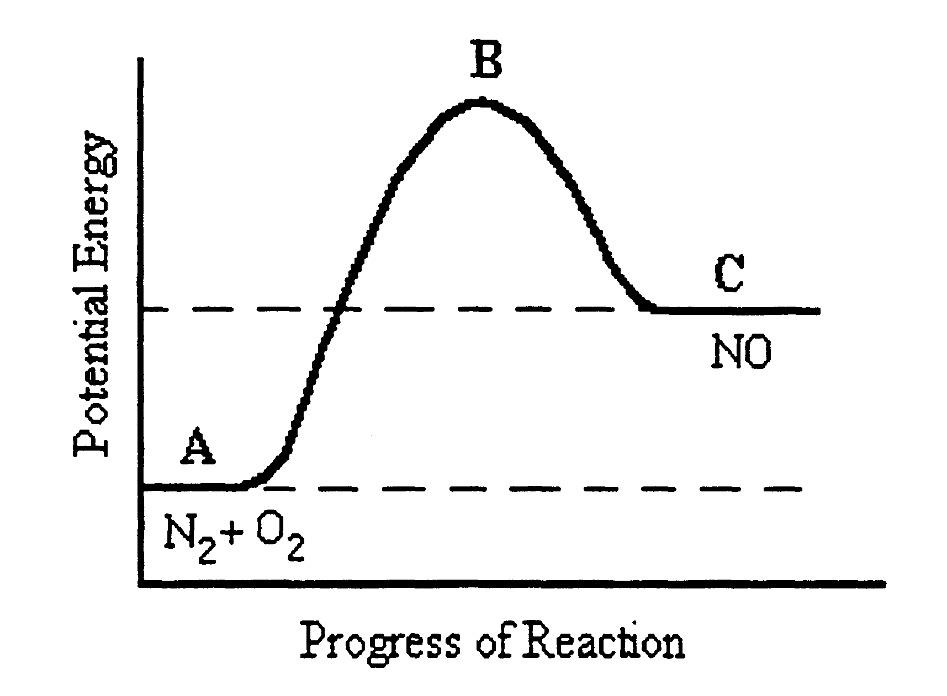

- Which of the following statements is FALSE?

  - The reaction is endothermic with ΔH = C – A.
  - The reactants have less potential energy than the products.
  - B represents the transition state.
  - The activation energy for the production of NO _{(g)} would be equal to B – C.
- The formation of nitrogen gas and oxygen gas from nitrogen oxide would have an enthalpy change of:

  - + 180 kJ
  - -180 kJ
  - + 90 kJ
  - - 90 kJ

- Which one of the following processes is endothermic?

  - Burning carbon
  - Condensing steam
  - Sublimation of Iodine
  - Adding Sodium to Water

- Which of the following contains the greatest number of moles of oxygen atoms?
  - 5 g of H₂O
  - 5 g of H₂O₂
  - 5 g of NO₂
  - 5 g of NO

- The following equation is unbalanced. When the equation is balanced, what is the stoichiometric ratio of Ba(OH)₂ to NH₃?

Ba(OH)₂ + (NH₄)₃PO4 Ba₃(PO₄)₂ + NH₃ + H₂O

  - 1 : 2
  - 1 : 3
  - 6 : 3
  - 2 : 1

- Which of the following has the greatest molar mass?
  - NH₄SCN
  - Na₃PO₄
  - CH₃COOH
  - Li₂CO₃

The next two questions (13 and 14) refer to the information below.

An experiment was performed to measure the amount of oxygen gas evolved at ten second intervals, when 40 mL of hydrogen peroxide was allowed to decompose according to the equation:
_{MnO2}
2H₂O_{2 (ℓ)}  2H₂O _{(ℓ)} + O_{2 (g)}

The reaction was carried out at 20ºC and 0.5 g of manganese dioxide added at the start of the experiment. The results are shown in the graph on the next page.
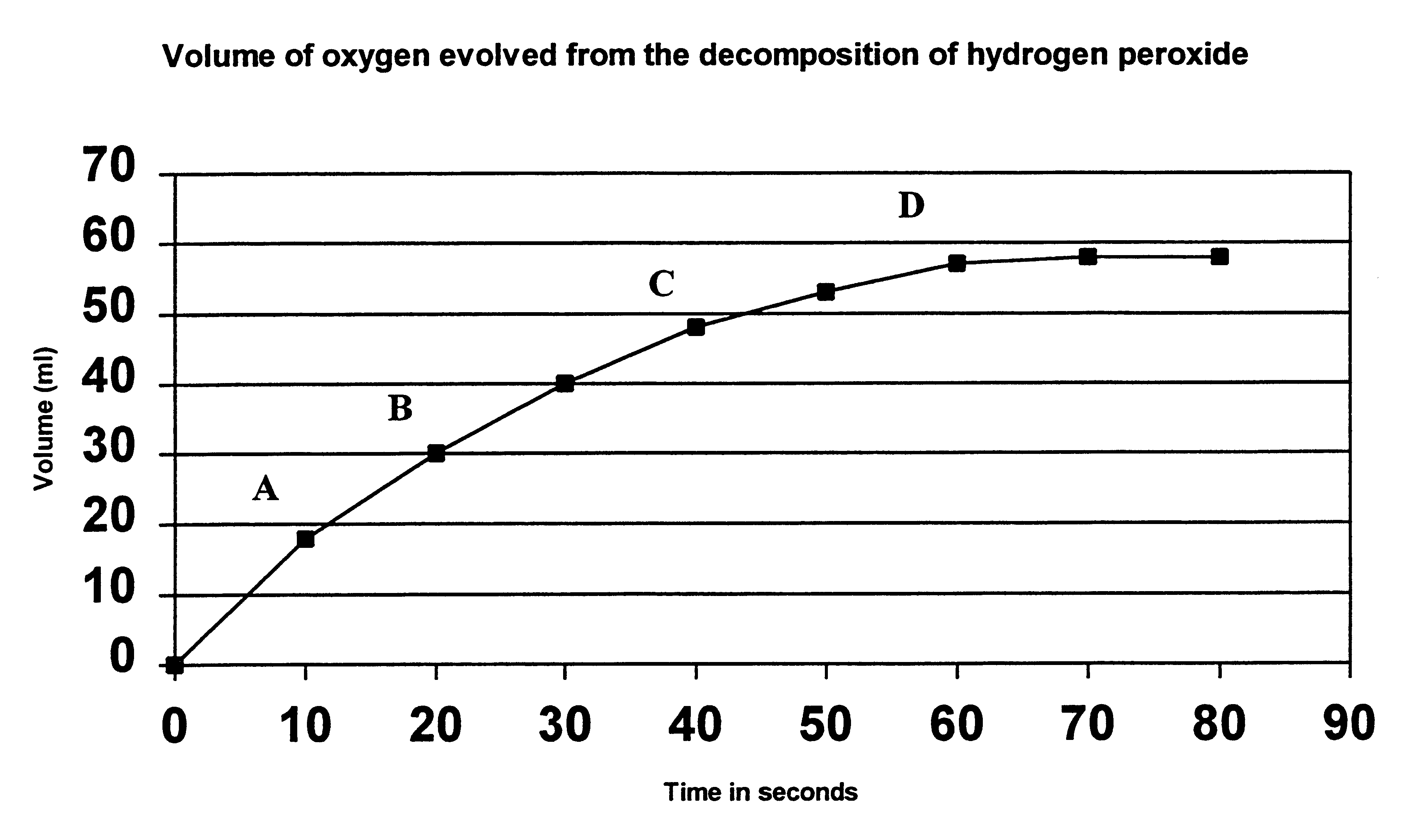
- At what interval is the RATE of reaction greatest?
  - Between 0 and A.
  - Between A and B.
  - Between B and C.
  - Between C and D.

- Which of the graphs below would best show the two sets of expected results gathered from the decomposition of hydrogen peroxide at 20ºC and again at 80ºC?

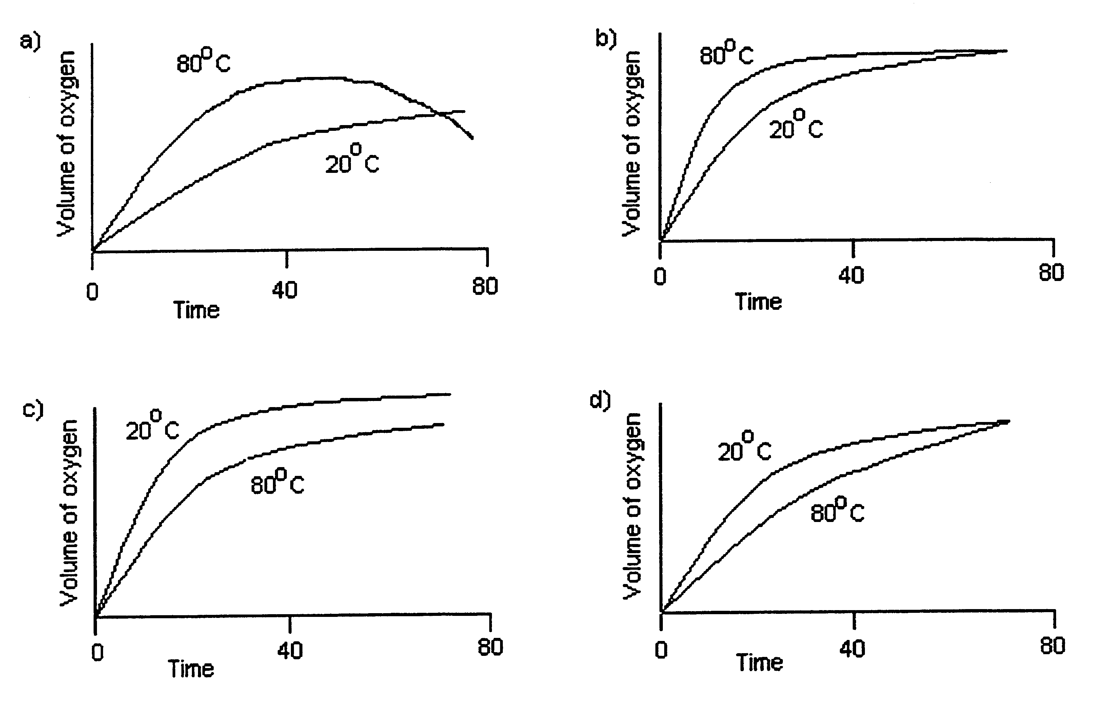
END OF MULTIPLE CHOICE SECTION

